**2023 May Day MCM**

**Problem B. Express demand analysis problem**

As a basic consumption mode, online shopping drives the rapid growth of express service demand and makes an essential contribution to the development of the economy in China. It is of great significance to accurately predict the demand quantity of express transportation for express companies to layout warehouse sites, save storage costs, and plan transportation routes. Attachment 1, Attachment 2, and Attachment 3 are the express transportation data between several cities recorded by a domestic express company, including the date of delivery, the city of delivery, and the city of receipt (actual city names have been replaced with letters). The data for June, November, and December have been excluded. Please establish mathematical models according to the attached data to complete the following problems:

**Question 1**: Attachment 1 is the express transportation data between the cities of the stations (delivering-receiving) recorded by the express company from April 19, 2018, to April 17, 2019. Please consider the number of goods received and delivered, the growth/decline trend of express delivery, correlations, and other aspects to establish a mathematical model and comprehensively rank the importance of each station city. Please give the names of the top 5 site cities and fill in the results in Table 1.

Table 1 Results for Question 1

|  |  |  |  |  |  |
| --- | --- | --- | --- | --- | --- |
| Rank | 1 | 2 | 3 | 4 | 5 |
| City name |  |  |  |  |  |

**Question 2**: Please use the data in Attachment 1 to establish a mathematical model to predict the number of expresses between cities of each "delivering-receiving" station on April 18, 2019, and April 19, 2019, as well as the total number of expresses between cities of all "delivering-receiving" stations on that date. Please fill in the number of expresses between the specified site cities and the total number of expresses between all "delivering-receiving" site cities on that day in Table 2.

Table 2 Results for Question 2

|  |  |  |  |
| --- | --- | --- | --- |
| Date | Number of expresses between the specific "delivering-receiving" station | | Total number of expresses between all  "delivering-receiving" station |
| April 18, 2019 | M-U |  |  |
| Q-V |  |
| K-L |  |
| G-V |  |
| April 19, 2019 | V-G |  |  |
| A-Q |  |
| D-A |  |
| L-K |  |

**Question 3**: Attachment 2 is the number of expresses recorded by the express company from April 28, 2020, to April 27, 2023. Due to the impact of emergencies, the express routes between some cities cannot be used for transportation normally, resulting in the failure to deliver or receive goods between the cities of the stations (no data means that the expresses cannot be received or delivered normally, 0 means that there is no delivery demand). Please use the data in Attachment 2 to build a mathematical model to predict the normal "delivering-receiving" site city pairs (Delivering city-receiving city) on April 28, 2023, and April 29, 2023, and determine whether the specified site city pairs in Table 3 can be delivered normally. If so, give the corresponding express transportation quantity and fill in the results in Table 3.

Table 3 Results for Question 3

|  |  |  |  |
| --- | --- | --- | --- |
| Date | "Delivering-receiving"  site city pairs | Whether the expresses can be delivered normally  (Fill in "Yes" or "No") | Number of expresses |
| April 28, 2023 | I-S |  |  |
| M-G |  |  |
| S-Q |  |  |
| V-A |  |  |
| Y-L |  |  |
| April 29, 2023 | D-R |  |  |
| J-K |  |  |
| Q-O |  |  |
| U-O |  |  |
| Y-W |  |  |

**Question 4**: Figure 1 shows the intercity rail transportation network of all stations. The cost of rail transportation is calculated by the following formula: cost = fixed cost ×[1+(actual/rated load)^3]. In this case, it is assumed that the actual shipment is allowed to exceed the rated shipment. The fixed cost and rated loading of all railways are given in Attachment 3. When transporting express, it is required that no more than 5 routes can be used between the cities of each "delivering-receiving" site city pair. Please build a mathematical model to give the lowest cost transportation scheme for the express company. Using the data in Attachments 2 and 3, calculate the company's daily minimum transportation cost from April 23 to 27, 2023, and fill in Table 4.

Note: For the convenience of calculation, the weight and size of the express are not differentiated. It is assumed that the weight of each express is 1 unit. Only transportation costs are considered, and other costs, such as transit costs, are not considered.

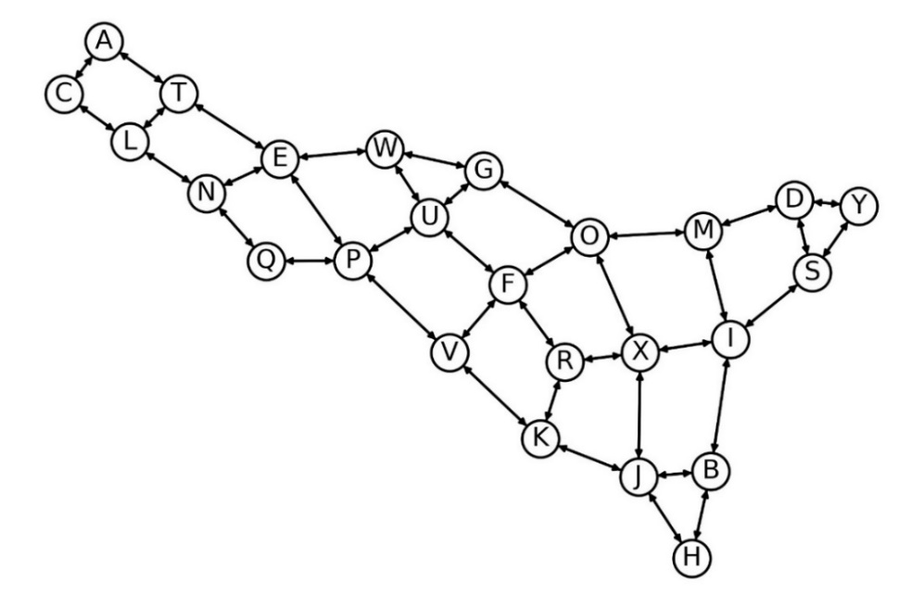

Figure 1 Railway transport network between station cities

Table 4 Results for Question 4

|  |  |
| --- | --- |
| Date | Minimum transport cost |
| April 23, 2023 |  |
| April 24, 2023 |  |
| April 25, 2023 |  |
| April 26, 2023 |  |
| April 27, 2023 |  |

**Question 5**: Generally, express demand consists of two parts. The first part is fixed demand, which comes from daily necessary online shopping consumption (generally, it cannot be simply identified as the minimum value of historical data of express demand, which is usually less than the minimum value of demand). The second part is the non-fixed demand, which usually fluctuates wildly and is greatly affected by time and other factors. Assume that in the same quarter, the fixed demand of the city pair of the same "delivering - receiving" site is a definite constant (hereinafter referred to as fixed demand constant); The non-fixed demand of the city pair of the same "delivering-receiving" site follows a probability distribution (the mean and standard deviation of the distribution are called the mean of non-fixed demand and the standard deviation of non-fixed demand respectively). Please use the data in Attachment 2, without considering the excluded data, no delivery demand data, and non-normal delivery data, and answer the following questions:

(1) Establish a mathematical model, estimate the fixed demand constant quarterly, and verify its accuracy. Fill in Table 5 with the fixed demand constants of city pairs of designated quarter and designated "delivering - receiving" site, as well as the sum of fixed demand constants of all "delivering - receiving" city pairs in the same quarter;

(2) Give the estimation method of the probability distribution of non-fixed demand, and fill in Table 5 with the mean value and standard deviation of non-fixed demand of city pairs in the designated quarter and designated "delivering - receiving" site, as well as the sum of the mean values of non-fixed demand and total standard deviations of non-fixed demand of all "delivering-receiving" city pairs in that quarter.

Table 5 Results for Question 5

|  |  |  |  |  |
| --- | --- | --- | --- | --- |
| Quarter | The third quarter of 2022  (From July to September) | | The first quarter of 2023  (From January to March) | |
| "Delivering - receiving" city site pair | V-N | V-Q | J-I | O-G |
| Fixed demand constant |  |  |  |  |
| The mean of non-fixed demand |  |  |  |  |
| The standard deviation  of non-fixed demand |  |  |  |  |
| The sum of the fixed demand constants |  | |  | |
| The sum of the mean of non-fixed demand |  | |  | |
| The sum of the standard deviation of non-fixed demand |  | |  | |